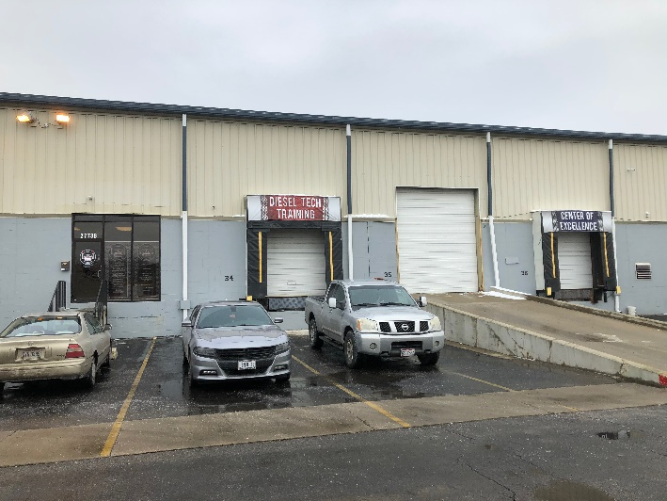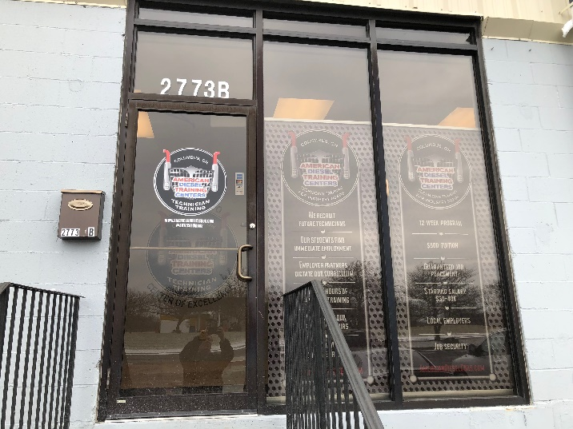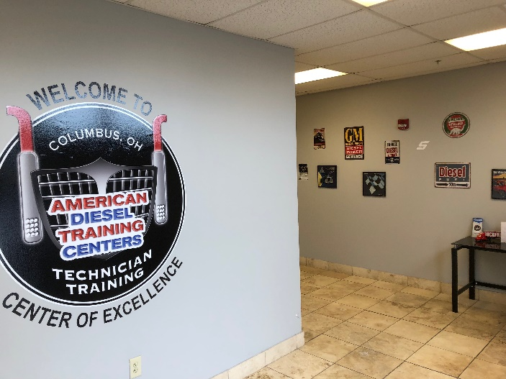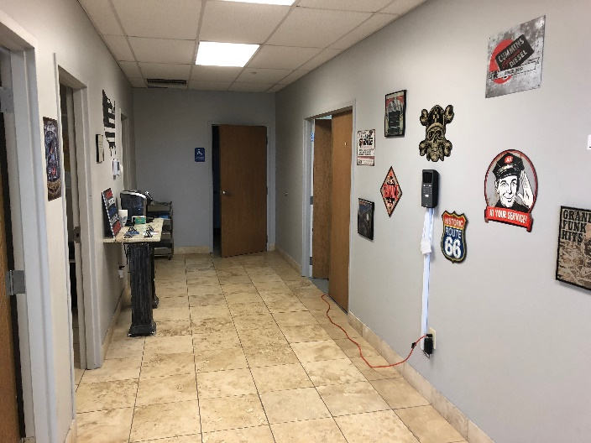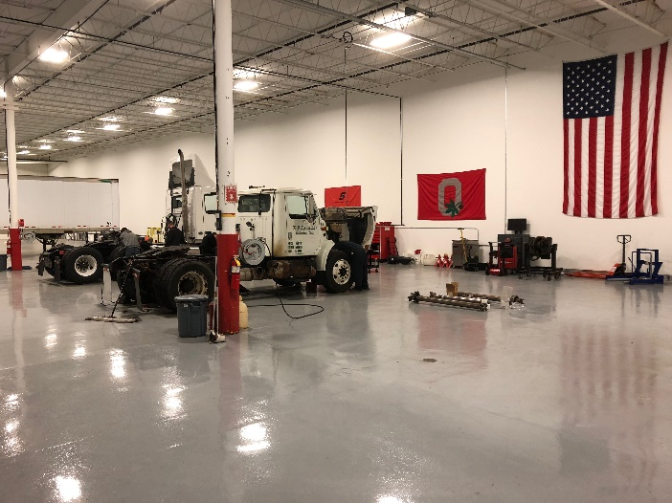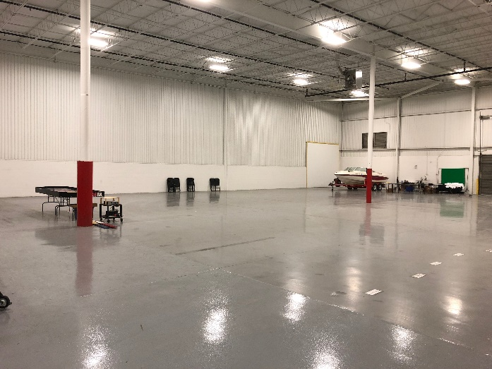
This is the American Diesel Training Centers facility where the 2018 Ohio Cup will be held. The address is 2773 Westbelt Dr, Columbus, Ohio, 43228. Like the name says, we are a diesel technician training facility. That’s why there will be some strange items in and around this racing venue. Don’t worry, we have plenty of space to set up tracks, pit spaces, food, and everything we need to have a great day of racing. Restaurants and hotels are close by so you don’t have to go far for refreshments. Food and drinks will be provided the day of the race.

