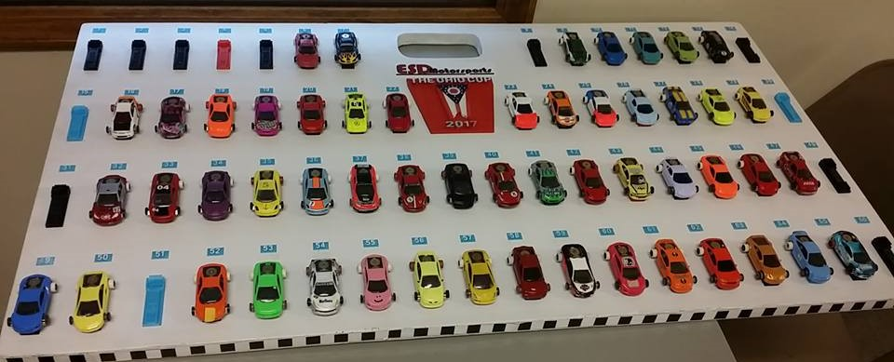

The Ohio Cup will be held on Saturday May 5th, 2018. Doors will open at 8:00am with some time for testing before the drivers meeting and pre-race tech inspection at 10:00am. Racing will start as soon as meeting and tech are finished and will run as long as we need into the night. We will not be restricted on time. Friday May 4th, will be open practice from 8:00am until 10:00pm that night. All tracks will be available to practice on the entire day. Local racers are asked to allow those coming in later in the day some priority for practice time.

